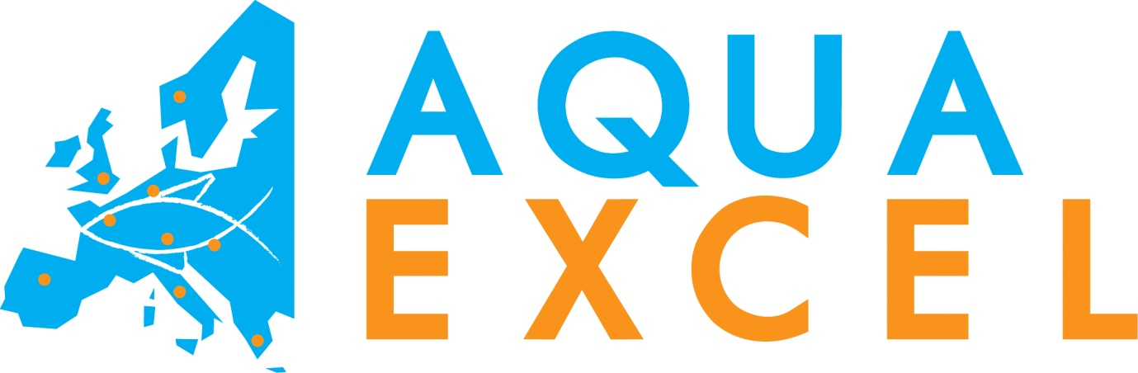

Online Institution Info Template for AQUAEXCEL institutions

www.aquaexcel.eu
Contents
Contents 2
1.Introduction/explanation for partners 3
2.AQUAEXCEL project information 3
3.How to access our Research Facility 4
4.[Institution name] in AQUAEXCEL 4
1.Introduction 4
1.[Name of Research Infrastructure 1] 4
1.1.Fish Line information 6
1.2.Facility Unit 1 Information [Name of Facility Unit 1] 6
1.3.Facility Unit 2 Information – [name] 8
2.Modality of access 8
3.Unit of access 8
4.News and Updates 8

Introduction/explanation for partners
The AQUAEXCEL project is developing an online interactive system for registration of Research Infrastructure (RI) properties, which will be available on the project website: http://www.aquaexcel.eu/. A lot of information on Research Infrastructures of AQUAEXCEL partner institutions will be uploaded and viewable in this system. However, some further detailed information will not be available through this system, and the idea is that each AQUAEXCEL partner develops a dedicated page on their own institutions website with this further information. This document provides you with a template for this page, detailing the information that should be displayed. The following should be displayed, which will be specified below:
- AQUAEXCEL (general) project information
- How to access our Research Facility
- [Institution name] in AQUAEXCEL
  - Introduction
  - [Research Infrastructure 1]
    - Fish Line Information
    - Facility Unit 1 Information
    - Facility Unit 2 Information
    - Etc
  - [Research Infrastructure 2]
    - Etc
  - Modality of Access
  - Unit of Access
  - Updates
We also encourage institutions to include as many photos and videos of your facilities as possible.
Please inform Marieke Reuver (marieke@aquatt.ie), John Bostock (j.c.bostock@stir.ac.uk) and Benedicte Ferreira (benedicte.ferreira@paris.inra.fr) once you have launched this website page, so we can incorporate this in the AQUAEXCEL website, online interactive system and any other relevant places.
The following text gives you the template to use on your institution website page dedicated to AQUAEXCEL.
Text in black is template that should be copied to your website as it stands. Text in light blue and italic is instructions and explanations, and should not be copied to your website. If you have any questions, please do not hesitate to contact Marieke (marieke@aquatt.ie).

AQUAEXCEL project information

IFREMER is partner in the FP7 project AQUAEXCEL (http://www.aquaexcel.eu/), funded by the European Commission and launched in March 2011. AQUAEXCEL aims to coordinate and improve access to top class European aquaculture research facilities. On a regular basis, the project invites proposals from European research groups to utilize the facilities of any of the participating 23 Aquaculture Research Infrastructures.
For more information on the project, please consult www.aquaexcel.eu

How to access our Research Facility
Researchers from any EU or Associated State can apply for access to any of the AQUAEXCEL Research Infrastructures. Applications must be made to use a Research Infrastructure in a different country to that of the lead researcher. Details of the other Research Infrastructures available within AQUAEXCEL can be found on www.aquaexcel.eu and on each institution website.
Each Research Infrastructure has a budget based on units of access, which are detailed for IFREMER on this page. Access to the facilities is provided free of charge to users and travel and subsistence expenses will also be paid. In general, it is anticipated that access will be in the form of one or in some cases two scientists travelling to work at one of the Research Infrastructures for a period of between one and three months.
Applications for Transnational Access may be made by any organisation (including commercial companies), but the conditions of access require the results of the work to be published and made available to the scientific community via standard channels.
Applications for Transnational Access should be made in accordance with the guidance published in regular “Calls for Proposals” that are made available on the project website (www.aquaexcel.eu). Applicants are also encouraged to directly contact individual facilities to discuss their research plans in advance of submitting an application.
Applications for Transnational Access will be reviewed by an expert selection panel and an independent ethics adviser. Projects selected for Transnational Access will be expected to demonstrate high scientific quality, make efficient use of resources and effectively address issues important for the development of European aquaculture – e.g. as expressed through the Strategic Research Agendas of the European Aquaculture Technology and Innovation Platform (www.eatip.eu).
All Transnational Access projects must be carried out between October 2011 and January 2015. It is anticipated that individual Research Infrastructures will only be included in the six-monthly calls for access as long as there are remaining units of access available.

IFREMER in AQUAEXCEL

Introduction

Operating institution: | IFREMER (Institut Français pour l'Exploitation de la Mer).  (French Institute for the Exploiation of the Sea)  http://wwz.ifremer.fr/institut
Type Operating Institution: | Research Institute
Research Infrastructure(s): | 1)-Marine Eco-tolerance section (MES)  2)- Experimental facilities for marine fish larvae (MFL)

  - Marine Eco-tolerance section (MES)
Name of the infrastructure: | Marine Eco-tolerance section (MES)
Location: | Chemin de Maguelonne  34250 Palavas les Flots  France
Web site address: | http://wwz.ifremer.fr/mediterranee/bienvenue
Contact: | Emmanuel REZZOUK  +33(0)467130400  Emmanuel.Rezzouk@ifremer.fr
AQUAEXCEL TNA facility: | Yes, and Marine Eco-tolerance section (MES) has facilities which are open for Access to external research groups within the framework of the AQUAEXCEL project.
Short description | The infrastructure offered to TNA activities, is located in a 4000m2 research station. It comprises a room (185 m2) of 12 same tanks each, running with seawater and working in flow through or in recirculated system.
Keywords | marine fish physiology, nutrition, feeding behaviour, genetics, welfare, domestication and recirculating rearing systems
Technical labs | Three technical labs are available for measurements in water chemistry (ammonia, nitrite, nitrate, phosphate..) fish pathology and preparations for molecular biology. The Ifremer station of Palavas is associated with nearby specialized laboratories in Montpellier (University, Cirad, INRA and IRD) which creates a scientific environment of good quality with numerous researchers involved in aquatic living resources and ecosystems.
Processing labs | No
EU projects | Benefish, Wealth, Aquamed, TNA-ASEFAF programme (2001-2004):
Number of researchers | 10
Number of technicians | 6
Lodging facilities | No lodging facilities on site, but the infrastructure has preferential relationships with a local real estate agency.
SERVICES - scientific support | Scientific advices, recommendations and/or explanations could be given by several of the seniors scientists on site.
SERVICES - electronic databases | Access to the La Pérouse- library: Archimer database and full text articles
SERVICES - quality assurance | ISO 90001 procedure for quality insurance in progress.
Safety and ethical issues | The technical team has a strong background and interest in the ethical treatment of fish and contains licence-holding members with the world’s strictest requirements for the ethical use of animals.  Any work carried out with fish will be undertaken with approval from local (e.g. university) or national ethical committees. All research, including that which requires anaesthetisation or euthanasia of fish will be carried out under the auspices of national licensing authorities.  Legal requirements for reduction, refinement and replacement of the use of animals in experimentation will also help to ensure ethical and parsimonious experimental design.
Other relevant information

Fish Line information: total number: 8

Name Fish Line 1: | West Mediteranean base population
Species: | Sea bass (dicentrarchus labrax)
General description | Wild Seabass, collecteted in the west of the Mediteranean sea (Lion Golf)
Type:
- Base population
Traits selected (if relevant):
Nb generations: 0
Effective population size: 20 males 20 femelles
Other:

Name Fish Line 2: | North Atlantic base population
Species: | Sea bass (dicentrarchus labrax)
General description | Wild Seabass, collecteted in the North Sea.
Type:
- Base population
Traits selected (if relevant):
Nb generations: 0
Effective population size: 46 femelles 18 males
Other:

Name Fish Line 3: | Growth
Species: | Sea bass (dicentrarchus labrax)
General description | 3nd generation of a massal selection on growth, based on North Atlantic wild population.
Type:
- Selected population
Traits selected (if relevant): Growth
Nb generations: 3
Effective population size: 2nd génération
36 femelles, 30 males (store in a cryo bank)

Other: The third génération is in the ongrowing facilities and will reach the broodstock in 2013. The second génération is still available in the breeding facilities. Selected an control males from the first generation are in a cryo-bank.

Name Fish Line 4: | SEX femelle +
Species: | Sea bass (dicentrarchus labrax)
General description | Fish selected for giving mostly femelle in their offspring (from 80% to 97% of femelles in the offspring), based on West Mediteranean wild population.
Type:
- Selected population
Traits selected (if relevant): Sex ratio in the offspring
Nb generations: 1 pressure of selection and 3 generations to maintain the line.
Effective population size: 40 femelles, 25 males
Some control fish (50% of femelles in the offspring) and contrasted fish (10% of femelles in the offspring) are still available (18 femelles alive and 14 males cryopreserved)

Other:

Name Fish Line 5: | Food Efficiency
Species: | Sea bass (dicentrarchus labrax)
General description | Fish selected for their good or bad Food Efficiency. Based on West Mediteranean wild population.
Type:
- Selected population
Traits selected (if relevant): Contrsated selections on starvation and post starvation growth corralated to Food Eficiency
Nb generations: 2
the fisrt generation is in broodstock, the second generation is in ongrowing)
Effective population size: 1st generation, 32 femelles, 63 males (54 cryopreserved and 9 alive).
2nd generation, not already sexed
Other:

Name Fish Line 6: | Vegetal
Species: | Sea bass (dicentrarchus labrax)
General description | Fish selected for their good growth performance with plant base diet, based on West Méditeranean wild population.
Type:
- Selected population
Traits selected (if relevant): Good or bad growth feed with plant base diet and controle fish feed with fish meal and oil diet.
Nb generations: 2
Effective population size: the first generation is in the broodstock and contain: 30 femelles, 30 males cryopreserved.
the control fishes: 30 femelles, 46 males cryopreserved.
The second generation is on ongrowing and will reach the broodstock in 2013.
Other:

Name Fish Line 7: | Albinos
Species: | Sea bass (dicentrarchus labrax)
General description | Albinos line.
Type:
- Selected population
Traits selected (if relevant): Albinos
Nb generations:
Effective population size: 300 fishes in ongrowing facilities, they will rich the broodstock in 2014.
Other:

Name Fish Line 8: | Atlantic Domesticated.
Species: | Sea bass (dicentrarchus labrax).
General description | First generation of domestication on the North Atlantic Population.
Type:
- Control population
Traits selected (if relevant):
Nb generations:1
Effective population size:26 femelles and 30 males.
Other:

Facility Unit 1 Information: Marine Eco-tolerance section

Name Facility Unit 1 | Marine Eco-tolerance section
TNA | Yes
Contact (Researcher) | Lemarié Gilles (glemarie@ifremer.fr)  +33 (0) 4 67 13 04 08
URL | [instructions: website address]
Postal Address | Station Ifremer. 34250 Palavas les Flots. France
General description | The infrastructure offered to TNA activities, is located in a 4000m2 research station. It comprises a room (185 m2) of 12 same tanks each, running with seawater and working in flow through or in recirculated system.
Technical description | The experimental tanks are 1 cubic meter each, black coated, u-shaped with a central outlet for efficient self cleaning. Each tank is covered with a black plastic sheet to protect fish against external visual stress. Light intensity (from 0 to 500 lux at the water surface) and the photoperiod including an artificial dawn and dusk can be controlled.  Tanks are fitted with efficient feeders and particule traps allowing a high level of the control of feed intake and uneaten feed, especially when fish are fed at satiation. For dedicated studies, feeders can be use on-demand by the fish in combination with a PIT-tag antenna device in 12 tanks in order to identify individual fish feed-demand. Therefore complex studies can be operated simultaneously at a significant scale, with a great number of replicates in these facilities quite rare and unique. These facilites are reliable as they run from some years.
Remote monitoring & control | No remote control via internet.
Water and environmental conditions | Sea water is sand-filtered at 15 *m, UV sterilised, heated or cooled and degassed in a packed column. Seawater is provided to tanks by gravity from an header tank with small overflow. This system guarantees a very stable water pressure for long periods at the inlet valve. Water temperature can be maintain in a range from 10 to 25°C. Water flowrate per tank ranges from 10% per hour to 250% per hour. Seawater can be enriched with oxygen or other gas by injecting an adequate flow in a bicone running under pressure.
Flowrate | Flow rate per confinement unit: 0,1 to 1,5 m3/h manually monitored.
Temperature | 10 to 25°C, monitored manually and controlled automatically.
Salinity | Stabilized in a range 10 °/oo to seawater salinity, parameter manually monitored and controlled.
Oxygen | Stabilized in a range 5 to 15 ppm, parameter manually monitored and controlled.
pH | Range 6,8 to 7,9, manually controlled.
Light intensity and wavelength | Light intensity (from 0 to 500 lux at the water surface) and the photoperiod including an artificial dawn and dusk can be automatically controlled.
Photoperiod | controlled automatically in a wide range 0 to 24h/d light.
Fish measurements | Sizes (various measurements) , weight, tag number and fat content are manually monitored and automatically recorded in a dedicated laptop.
Other / additional info
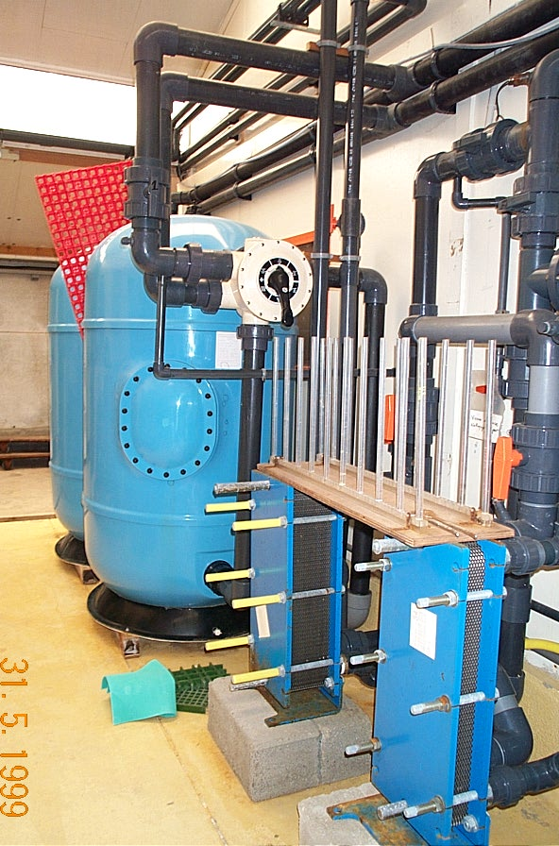
Pictures/videos
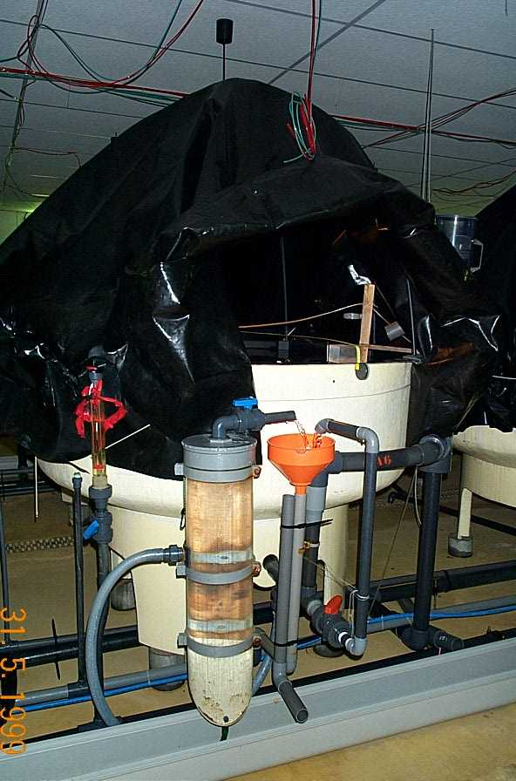
Water treatment system and one experimental 1m3 tank.

Modality of access
The access will comprise the use of the high-quality facilities and access to the laboratories. Fish will be available at various mean weight (2, 10, 50 or 150g) originated from strains genetically identified and reared in Palavas research station or from commercial farms located not far. The duration of the experiment can last until 2 months (3 months with the preparation time before experimentation and put back in service). Usually, trained and experienced staff will carry out the standard procedures and the general maintenance. Nevertheless, the external user will be strongly integrated in all processes.
Support offered under this proposal: The unit of access is defined as 1 tank/week, equalling the occupation of 1 standard fish holding unit (1m3) for 7 days. One trial is expected to comprise 12 tanks during 8 weeks. The access will comprise the use of tanks including fish supply, maintenance, water supply, daily feeding, handling, sampling and husbandry of fish. On request, access to laboratories facilities on site (water quality measurements and biometry) and other infrastructural, logistical, technical and scientific support to external users is offered. Scientific support will include advice on experimental design and methodology, documentation of results for all experiments conducted during the project, and appropriate sampling and conservation of samples. Outreach of new users: Potential new users will be informed about the access possibilities to Ifremer facilities of Palavas through calls for proposals targeting a specialised scientific audience. Finally, several teams will meet each other during the stay in Ifremer aquaculture research stations and can thus elaborate together a list of common interest research issues, making the Ifremer infrastructure as a place for the exchange of aquaculture scientific ideas.

Unit of access
The unit of access is defined as 1 tank/week, equalling the occupation of 1 standard fish holding unit (1m3) for 7 days. One trial is expected to comprise 12 tanks during 8 weeks.

